March:

Cross Section A:

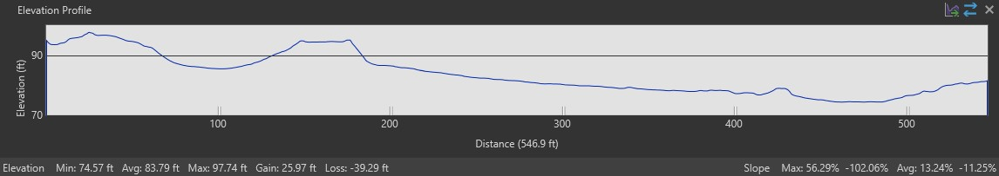

Cross Section B:

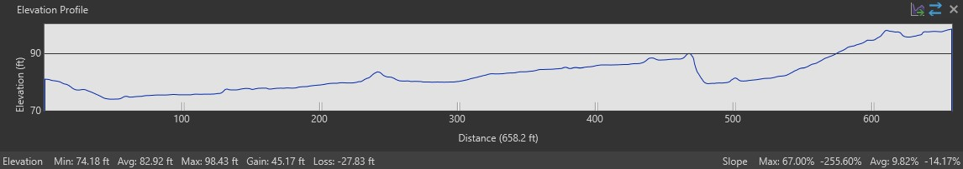

Cross Section C:

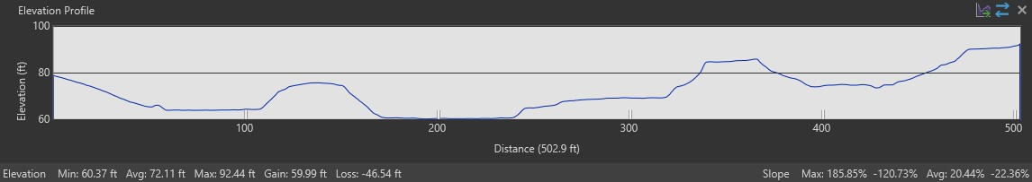

Cross Section D:

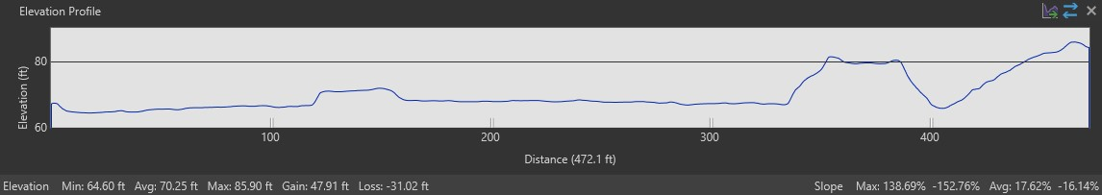

Cross Section E:

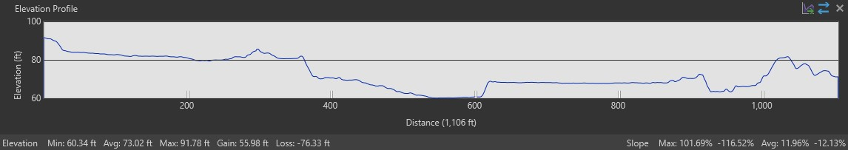

September:

Cross Section A:

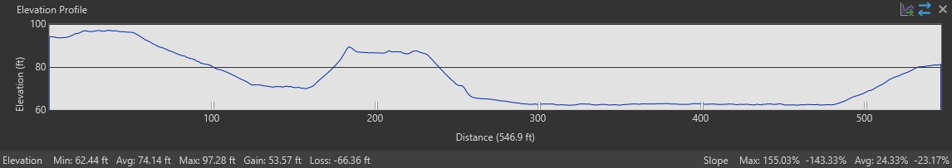

Cross Section B:

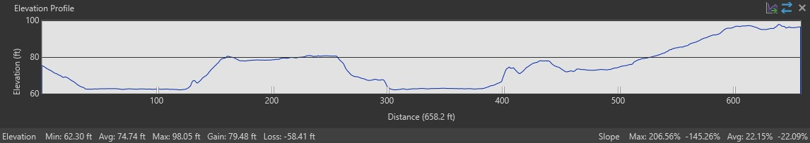

Cross Section C:

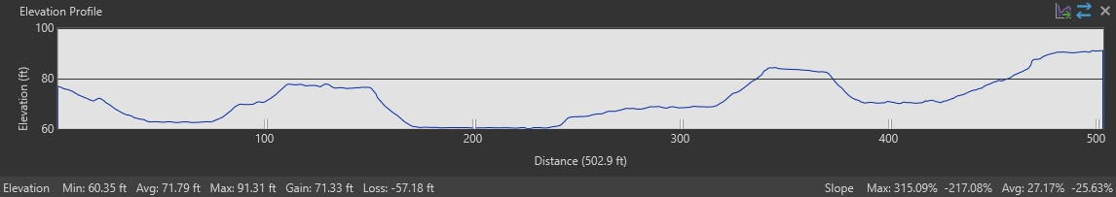

Cross Section D:

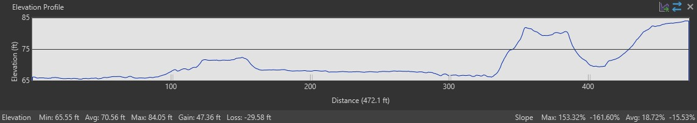

Cross Section E:

